Computer Architecture Lab
(EL-2012)
LABORATORY REPORT

Fall 2026

(Lab#_01_)
Write Lab Title Here

Student Name: ___Abdulmoeiz_______ Roll No: _______24i-6510_________ Section: __CE A_

Date performed: ____18 August____, 2026

MARKS AWARDED: ________ / 10

Signature and date of Instructor: _________________
Lab Instructors: Dr. Nasir Ali Shah, Engr. Fasih Ahmad

______________________________________________________________________________________________________________________________________________________

NATIONAL UNIVERSITY OF COMPUTER AND EMERGING SCIENCES, ISLAMABAD
Prepared by: | Fasih Ahmad |  | Version: 1.0
Verified by: | Dr. Nasir Ali Shah |  | Updated: Fall 2026

Task 1:

Description:
This task was focused on the basics of Verilog and allowed us to implement codes of Basic gates in Structural modelling. It allowed me to navigate through the Modelsim software and also how the testbench module is necessary for testing functionality. We also learnt about the timestamp and how we can interact directly with the hardware

Code:
AND Gate Code:
module gates(a,b,c);
input a, b;
output c;
and(c,a,b);
endmodule

module testbench();
reg x,y;
wire z;
gates uut(x,y,z);

initial
begin
x = 0; y = 0;
#50
x = 0; y = 1;
#50
x = 1; y = 0;
#50
x = 1; y = 1;
end
endmodule

OR Gate Code:
module gates(a,b,c);
input a, b;
output c;
or(c,a,b);
endmodule

module testbench();
reg x,y;
wire z;
gates uut(x,y,z);

initial
begin
x = 0; y = 0;
#50
x = 0; y = 1;
#50
x = 1; y = 0;
#50
x = 1; y = 1;
end
endmodule

NOR GATE Code:
module gates(a,b,c);
input a, b;
output c;
nor(c,a,b);
endmodule

module testbench();
reg x,y;
wire z;
gates uut(x,y,z);

initial
begin
x = 0; y = 0;
#50
x = 0; y = 1;
#50
x = 1; y = 0;
#50
x = 1; y = 1;
end
endmodule
NAND GATE Code:
module gates(a,b,c);
input a, b;
output c;
nand(c,a,b);
endmodule

module testbench();
reg x,y;
wire z;
gates uut(x,y,z);

initial
begin
x = 0; y = 0;
#50
x = 0; y = 1;
#50
x = 1; y = 0;
#50
x = 1; y = 1;
end
endmodule
XOR GATE Code:
module gates(a,b,c);
input a, b;
output c;
xor(c,a,b);
endmodule

module testbench();
reg x,y;
wire z;
gates uut(x,y,z);

initial
begin
x = 0; y = 0;
#50
x = 0; y = 1;
#50
x = 1; y = 0;
#50
x = 1; y = 1;
end
endmodule

XNOR GATE Code:
module gates(a,b,c);
input a, b;
output c;
xnor(c,a,b);
endmodule

module testbench();
reg x,y;
wire z;
gates uut(x,y,z);

initial
begin
x = 0; y = 0;
#50
x = 0; y = 1;
#50
x = 1; y = 0;
#50
x = 1; y = 1;
end
endmodule

NOT GATE Code:
module gates(a,c);
input a;
output c;
not(c,a);
endmodule

module testbench();
reg x;
wire z;
gates uut(x,z);

initial
begin
x = 0;
#50
x = 1;

end
endmodule

Output:
AND GATE SIMULATION:
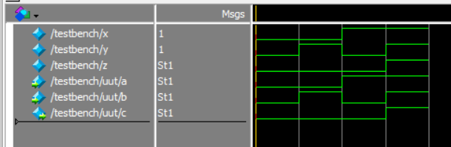
OR GATE SIMULATION:
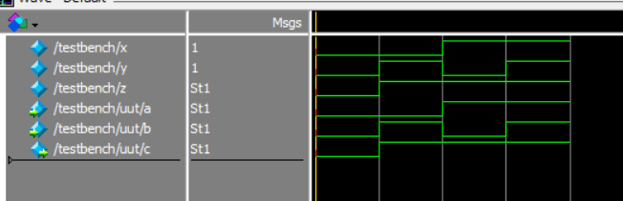
NOR GATE SIMULATION:
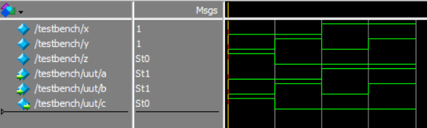
NAND GATE SIMULATION:
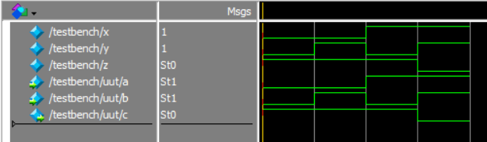

XOR GATE SIMULATION:
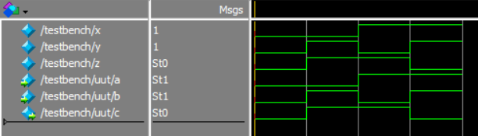
XNOR GATE SIMULATION:
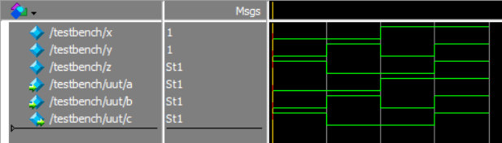
NOT GATE SIMULATION:
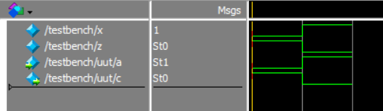
Task 2:

Description:
This task was again focused on the basics of Verilog and allowed us to implement codes of Basic gates in Dataflow modelling. It was different from previous task since we did not use any built in gate from ModelSim, instead we used the “assign” keyword. The testbench module was again necessary for testing functionality and used the same time delay method again

Code:
AND Gate Code:
module gates(a,b,c);
input a, b;
output c;
assign c = a & b;
endmodule

module testbench();
reg x,y;
wire z;
gates uut(x,y,z);

initial
begin
x = 0; y = 0;
#50
x = 0; y = 1;
#50
x = 1; y = 0;
#50
x = 1; y = 1;
end
endmodule

OR Gate Code:
module gates(a,b,c);
input a, b;
output c;
assign c = a|b;
endmodule

module testbench();
reg x,y;
wire z;
gates uut(x,y,z);

initial
begin
x = 0; y = 0;
#50
x = 0; y = 1;
#50
x = 1; y = 0;
#50
x = 1; y = 1;
end
endmodule

NOR GATE Code:
module gates(a,b,c);
input a, b;
output c;
assign c = ~(a|b);
endmodule

module testbench();
reg x,y;
wire z;
gates uut(x,y,z);

initial
begin
x = 0; y = 0;
#50
x = 0; y = 1;
#50
x = 1; y = 0;
#50
x = 1; y = 1;
end
endmodule
NAND GATE Code:
module gates(a,b,c);
input a, b;
output c;
assign c = ~(a&b);
endmodule

module testbench();
reg x,y;
wire z;
gates uut(x,y,z);

initial
begin
x = 0; y = 0;
#50
x = 0; y = 1;
#50
x = 1; y = 0;
#50
x = 1; y = 1;
end
endmodule
XOR GATE Code:
module gates(a,b,c);
input a, b;
output c;
assign c = a^b;
endmodule

module testbench();
reg x,y;
wire z;
gates uut(x,y,z);

initial
begin
x = 0; y = 0;
#50
x = 0; y = 1;
#50
x = 1; y = 0;
#50
x = 1; y = 1;
end
endmodule

XNOR GATE Code:
module gates(a,b,c);
input a, b;
output c;
assign c = a ~^ b;
endmodule

module testbench();
reg x,y;
wire z;
gates uut(x,y,z);

initial
begin
x = 0; y = 0;
#50
x = 0; y = 1;
#50
x = 1; y = 0;
#50
x = 1; y = 1;
end
endmodule
NOT GATE Code:
module gates(a,c);
input a;
output c;
assign c = ~a;
endmodule

module testbench();
reg x;
wire z;
gates uut(x,z);

initial
begin
x = 0;
#50
x = 1;

end
endmodule

Output:
AND GATE SIMULATION:
OR GATE SIMULATION:
NOR GATE SIMULATION:

NAND GATE SIMULATION:

XOR GATE SIMULATION:
XNOR GATE SIMULATION:
NOT GATE SIMULATION:

Task 3:

Description:
This task was based on the 2nd software of Logisim. This task was about the basic working and implementation of gates. This task allowed us to see how gates react to different combinations of inputs and allowed us to analyze through the TruthTable function. We implemented all the basic gates and saw their working.

Code:
AND GATE WORKING & TRUTH TABLE:

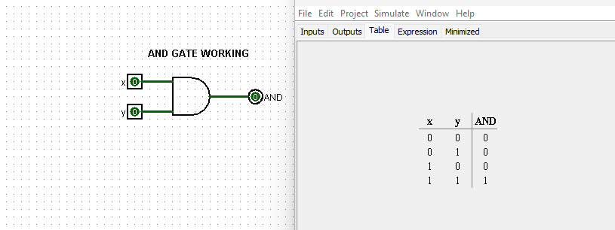

OR GATE WORKING & TRUTH TABLE:
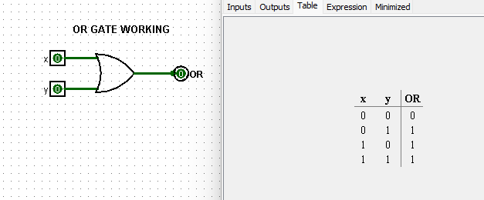

NOT GATE WORKING & TRUTH TABLE:
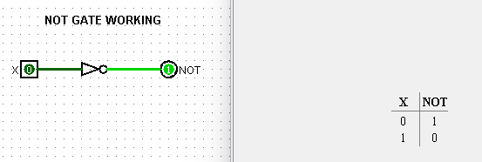

NOR GATE WORKING & TRUTH TABLE:
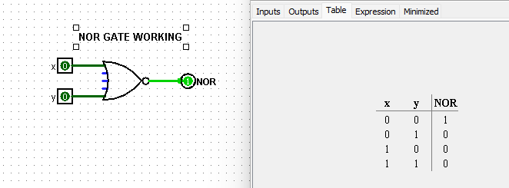

NAND GATE WORKING & TRUTH TABLE:

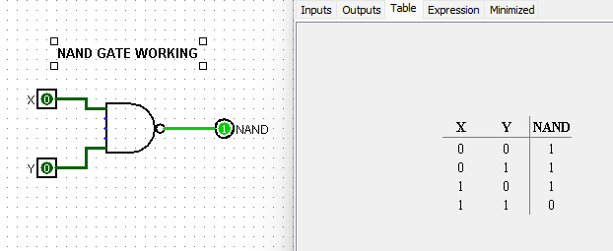

XOR GATE WORKING & TRUTH TABLE:

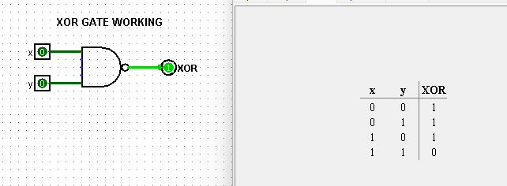

XNOR GATE WORKING & TRUTH TABLE:
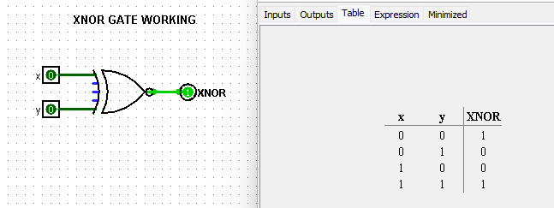

Output:

Task 4:

Description:
This was one of the main tasks of whole lab, where we coded a working circuit and saw how to deal with intermediate variables. We also coded the whole circuit in both GateLevel and Dataflow level models and at last we built a testbench function which allowed us to test our circuit and see how the intermediate outputs of gate behave through waveforms

Code:
GATE LEVEL CODE:
module circuit(a,b,g);
input a,b;
output g;
wire c,d,e,f;

not (c,a);
not (d,b);

and (e,c,b);
and (f,a,d);

or (g,e,f);
endmodule

module Circuit_TB();
reg x,y;
wire z;
circuit uut(x,y,z);

initial
begin
x = 0; y = 0;
#50
x = 0; y = 1;
#50
x = 1; y = 0;
#50
x = 1; y = 1;
end
endmodule

DATAFLOW LEVEL CODE:
module circuit(a,b,g);
input a,b;
output g;
wire c,d,e,f;

assign c = ~a;
assign d = ~b;

assign e = c&b;
assign f = a&d;

assign g = e|f;
endmodule

module Circuit_TB();
reg x,y;
wire z;
circuit uut(x,y,z);

initial
begin
x = 0; y = 0;
#50
x = 0; y = 1;
#50
x = 1; y = 0;
#50
x = 1; y = 1;
end
endmodule

Output:
GATE LEVEL SIMULATION:
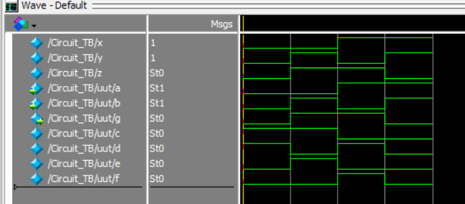
DATAFLOW LEVEL SIMULATION:

Task 5:

Description:
This task was the continuation of the task 4 where we built this the same circuit on Logisim software. This allowed us to learn how to connect different gates in different orientation and how to make a complete working circuit. At last confirmed the working of our circuit by looking at the circuit expression and TruthTable

Code:
LOGISIM CIRCUIT DAIGRAM + TRUTH TABLE

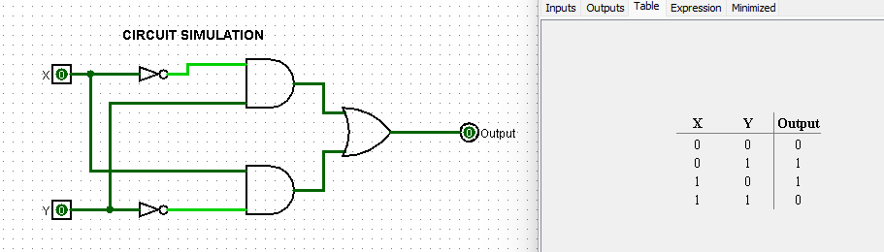

CIRCUIT EXPRESSION
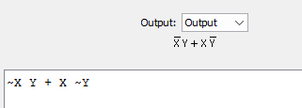
Output:

Task 6:

Description:
This task was asked us to perform 1’s compliment on 4 bits. 1’s compliment is an essential part of Logic and is used extensively. 1’s compliment is all about inverting the bits we have and that is what we implement through a not gate. This task was done through Gate Level as well as Data Flow level modeling as well and was tested via the testbench method.

Code:
1’s COMPLIMENT CODE Dataflow Level:

module gates(a,b,c,d,e,f,g,h);
input a, b, c, d;
output e, f, g, h;
assign e = ~a;
assign f = ~b;
assign g = ~c;
assign h = ~d;
endmodule

module testbench();
reg a1,b1,c1,d1;
wire e1,f1,g1,h1;
gates uut(a1,b1,c1,d1,e1,f1,g1,h1);
initial
begin
a1 = 1; b1 = 1; c1 = 0; d1 = 0;

end
endmodule

1’s COMPLIMENT CODE Gatelevel code:

module gates(a,b,c,d,e,f,g,h);
input a, b, c, d;
output e, f, g, h;
not(e,a);
not(f,b);
not(g,c);
not(h,d);
endmodule

module testbench();
reg a1,b1,c1,d1;
wire e1,f1,g1,h1;
gates uut(a1,b1,c1,d1,e1,f1,g1,h1);
initial
begin
a1 = 1; b1 = 1; c1 = 0; d1 = 0;

end
endmodule

Output:
SIMULATION OUTPUT TESTBENCH:

